**Wound analyzer v0.01**

Nazariy Jaworski 2016©

# Quick start

## Step 1: Run application

Run **WoundAnalyzer.exe** at corresponding directory.

The main window should appear:

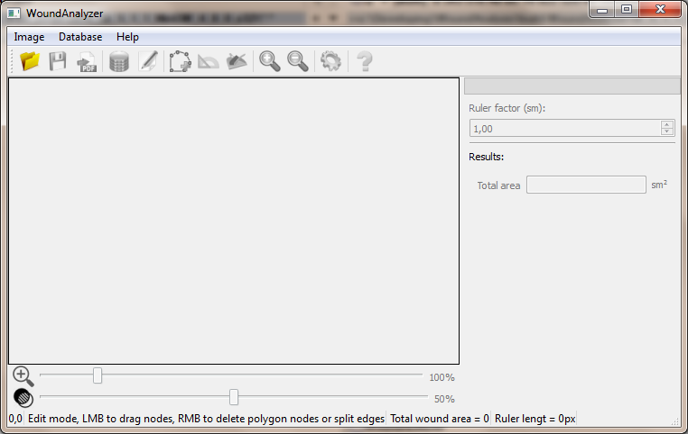

## Step 2: Open wound image

Open existing wound image by running **Image→Open…** action or by pressing icon:

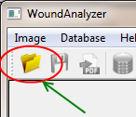

The File open dialog should appear:

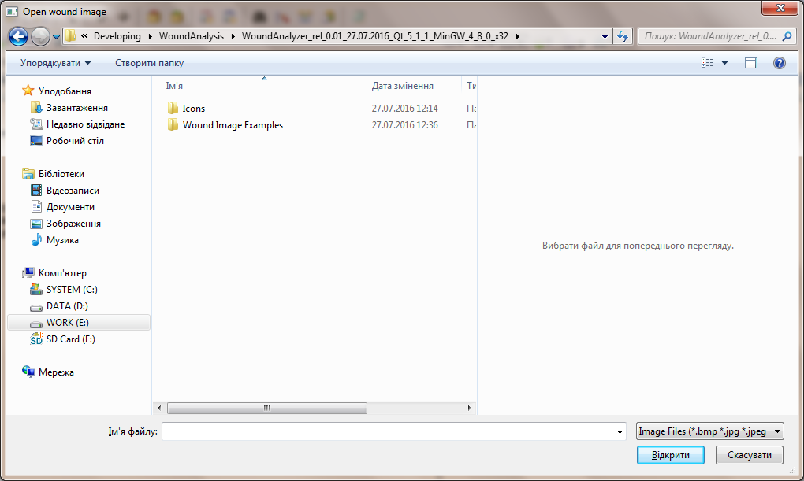

http://icons.iconarchive.com/icons/graphicrating/koloria/32/Warning-2-icon.png: supported image formats are **\*.bmp \*.jpg \*.jpeg \*.png \*.tif \*.tiff**

Example:

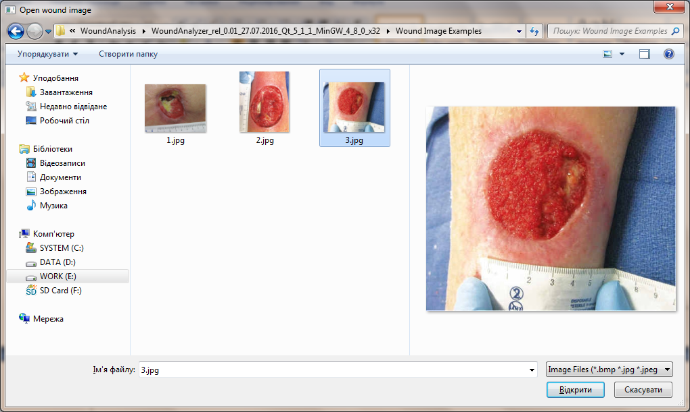

Press Open button, image should be opened now:

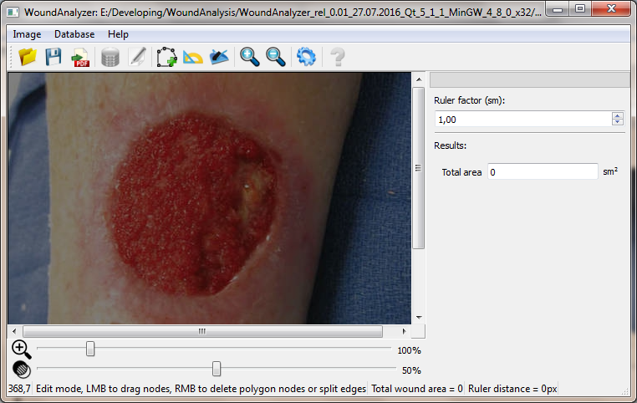

## Step 3: Select wound border(s)

Run **Image→Polygon** action or press corresponding button:

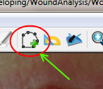

The application should be running in “Polygon mode”, see the status bar at the bottom.

Now simply do the mouse left button click on image to add nodes:

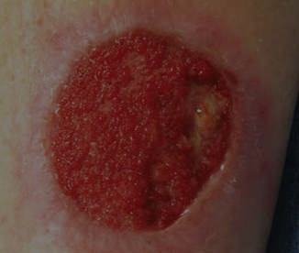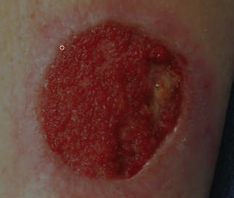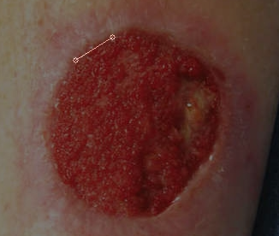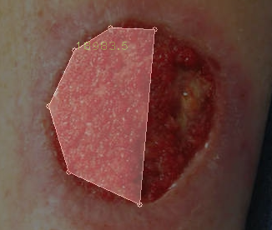

E:\Developing\WoundAnalysis\WoundAnalyzer_rel_0.01_27.07.2016_Qt_5_1_1_MinGW_4_8_0_x32\Icons\About.png It is possible to create more than one polygon – turn off the polygon mode by running **Image→Polygon** action then turn on it again. Previous polygon should be saved and new mouse click should create new polygon.

E:\Developing\WoundAnalysis\WoundAnalyzer_rel_0.01_27.07.2016_Qt_5_1_1_MinGW_4_8_0_x32\Icons\About.png If a mistake occurred the image can be cleared by running **Image→Clear** action or by pressing corresponding button:

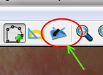

E:\Developing\WoundAnalysis\WoundAnalyzer_rel_0.01_27.07.2016_Qt_5_1_1_MinGW_4_8_0_x32\Icons\About.png Polygon can be edited – turn off the polygon mode by running **Image→Polygon** action. The application should be running in “Edit mode”, see the status bar at the bottom. The mouse cursor hovering over polygon nodes and edges should highlight them:

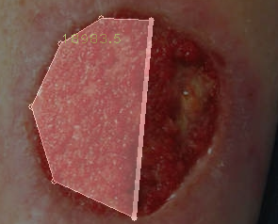

Each node can be dragged:

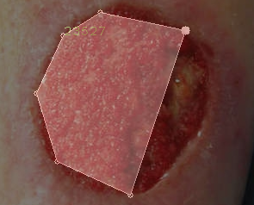

Each node can be deleted by right mouse button click over it:

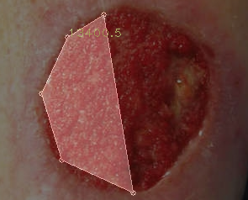

Each edge can be split by right mouse button click over it:

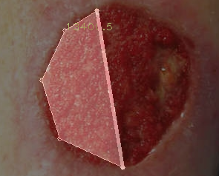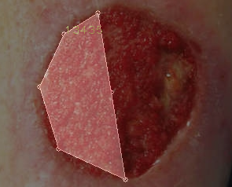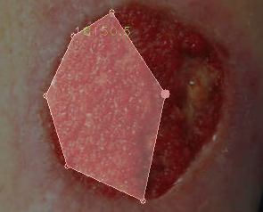

Use this features to select wound borders:

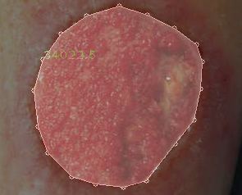

## Step 4: Scale wound borders by ruler

Run **Image→Ruler** action or press corresponding button:

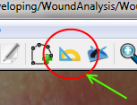

The application should be running in “Ruler mode”, see the status bar at the bottom.

Now simply do two mouse left button clicks on image to add ruler nodes:

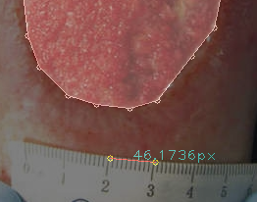

E:\Developing\WoundAnalysis\WoundAnalyzer_rel_0.01_27.07.2016_Qt_5_1_1_MinGW_4_8_0_x32\Icons\About.png Ruler can be edited – turn off the ruler mode by running **Image→Ruler** action. The application should be running in “Edit mode”, see the status bar at the bottom. The mouse cursor hovering over ruler nodes highlight them. Each node can be dragged.

## Step 5: Export results

Run **Image→Save** action or press corresponding button:

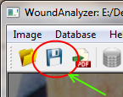

The Image save dialog should appear. Resulting image will be “what you see is that you get”:

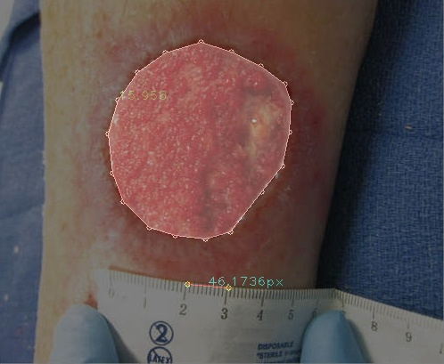

Run **Image→Export results** action or press corresponding button:

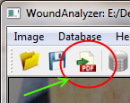

The Document save dialog should appear. Results will be saved in pdf format.